**RedRevive-Menstrual health Prediction using Machine learning**

Anant Kaulage  
*computer department*  
Vishwakarma institute of technology,punePune, India  
[anant.kaulge@vit.edu](mailto:anant.kaulge@vit.edu)

Shruti Khatal   
*computer department*  
Vishwakarma institute of technology,punePune, India  
  
Sujal Khardekar   
*computer department*  
Vishwakarma institute of technology,punePune, India  
[sujal.khardekar21@vit.edu](mailto:sujal.khardekar21@vit.edu)

Siddesh Khaple   
*computer department*  
Vishwakarma institute of technology,punePune, India

***Abstract*—***Menstrual health is a significant aspect of women's reproductive health, yet it remains a taboo subject in many societies. This paper provides an overview of existing research on menstrual health, with a focus on its impact on women's physical and mental well-being. The review draws on a range of studies, including qualitative and quantitative research, to highlight the challenges women face in managing their menstrual health and the consequences of poor menstrual health. Several interventions have been implemented to address these challenges, including policies, education, community-based interventions, and technological innovations. These interventions have been effective in improving menstrual health outcomes, such as reducing absenteeism and improving school attendance, promoting gender equality, and improving overall health and well-being.*

*The paper concludes by highlighting the need for increased awareness and advocacy around menstrual health, with a particular emphasis on addressing the socio-cultural barriers that hinder women's access to menstrual products, facilities, and education. The findings suggest that promoting menstrual health and well-being is critical to advancing gender equity and empowering women to lead healthy and fulfilling lives.*

***Keywords—*** ***Menstrual Hygiene, Google colab, Flask, Machine Learning, Health Care , Sociocultural Attitude.***

# **Introduction**

In the modern world women's faces many problems in their day to day life, one of them is menstruation, there are some regions where there is lack of awareness related to menstruation. So looking at these problems this project helps to spread awareness and also to predict the health outcomes related to womens during menstruation. Data was collected through google from and 306 girls from different places, ages gave information including various questions regarding their menstrual health which includes cramps, severity of cramps, moods swings, diet, mental health, product used during menstruation, questions and opinion related to periods, various symptoms during MC, medication or alternative therapies used in MC, menstrual flow, belonging area, water consumption during periods, any depression or anxiety, regularity of periods, menstrual cycle tracking, satisfaction about MC management and more.

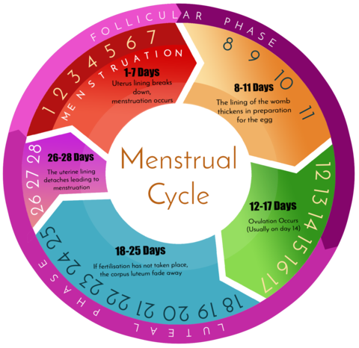

Fig no:1 Menstrual Cycle

Education for girls can be significantly impacted by menstruation. Dropouts from school are frequently caused by a lack of access to period hygiene products, sanitation facilities, and menstrual health education. Programmes for menstrual health aim to educate girls and give them the tools they need to effectively manage their periods while attending school.

Different cultures and people adhere to and believe in menstruation superstitions differently. It's crucial to remember that not all women follow specific superstitions during menstruation, and that customs differ greatly around the globe. It is important to understand that cultural customs and beliefs related to menstruation can have both beneficial and harmful effects. While certain customs may foster a sense of cultural identity or of community, others may promote negative stereotypes, prejudice, or limit the autonomy and participation of women in society.

In the end, it's critical to respect people's cultural practices and beliefs while also working to spread accurate information, combat harmful stigmas, and guarantee that those who menstruate have the support, resources, and legal rights to manage their menstrual health in a respectable and safe manner.

# **Literature Review**

The paper describes the findings from data mining algorithms used to estimate the likelihood that migraine symptoms will arise in women of reproductive age in relation to variations in menstrual cycle parameters. On the basis of logistic regression models created using three alternative approaches, the analysis was conducted. Determined were the links between fluctuations in menstrual flow, cycle regularity, and the start of migraine symptoms.[8]. This study aims to create a mobile phone application for tracking and managing information about women's health. This mobile application, which goes by the name of i-appli.The body's surface temperature is automatically measured while you sleep using a wearable temperature logger device. Mobile phones are used to send the temperature data that has been collected to a particular database server. This information is used to determine a woman's menstrual cycle, anticipate her next ovulation, and provide self-care services [6].Women of reproductive age are afflicted by the chronic condition known as endometriosis. Its primary symptoms include chronic pelvic pain, dysmenorrhea, and dyspareunia; pain impairs the patient's quality of life and has negative effects on her health. These characteristics were connected to anamnestic information, anxiety, and sadness. We gave the right tests (QUID - Italian Pain Questionnaire, Biberoglu's Scale, and HADS Scale) to gauge these factors, and we looked at how they related[11].  
 It is time for the GDC, which has focused on topics like gender and health, to highlight how resolving MHH may help with the SDGs (Sustainable Development Goals). To close this gap, we worked together to identify how MHH contributes to important sectoral areas of importance to menstruating girls in low- and middle-income countries as well as to priority outcome measures within those sectors. Education, gender, and health (that includes sexual and reproductive health) were among them [10]. For women and young ladies to have poise and strength, proper management of menstrual hygiene is essential.In any case, it is a neglected issue that affects both the health and general population, creating a need for information, offices, and hygienic practices. A web application to increase public awareness of menstruation in order to eradicate concerns with feminine hygiene and social issues. This is mostly meant to demonstrate them clearly to younger ages[7]. The study demonstrates that the girls experience discomfort, embarrassment, and stress as a result of their poor menstrual hygiene, which is caused by a lack of awareness, cultural and traditional practices, socioeconomic constraints, and environmental factors. This affects the girls' human rights by causing decreased school attendance, subpar academic performance, or even dropouts.[1]. Results obtained from study of about 212 people—206 from urban slums and 212 from rural areas—of whom 9% (19) were from rural areas and 5.3% (11) were unaware of the usage of sanitary pads during menstruation. 42.5% (90) of the participants in the survey who lived in rural areas and 40.3% (83) of those in urban areas did not know which organ menstruation comes from. According to the menstrual hygiene index, improved menstrual hygiene habits were more common than average in urban slums (63.6% of 131) and rural areas (35% of 75), which was statistically significant (P 0.0001) [2]. Although school-aged teenagers have a reasonable amount of information about managing menstrual hygiene, attitudes and practices still need to be improved. Results show that behavior change communication campaigns and constant reinforcement of school health education programmes are both necessary. The primary goal of the study was to assess the knowledge, attitudes, and practices of school-aged teenagers in the Doti district regarding MHM [3]. In India, there are many myths and misconceptions about menstruation, as well as a comprehensive list of "do's" and "don'ts" for women. Women's hygiene-related behaviors during menstruation are extremely important since they may make them more susceptible to RTIs.One of the main causes of the high frequency of RTIs in the nation and a substantial contributor to female morbidity is poor menstrual hygiene. The majority of teenage girls in communities wear rags and old garments while they are menstruating, making them more vulnerable to RTIs [5].

# **Data Selection & Description**

The following factors are taken into consideration when gathering the data of 307 participants during data collection: age, region, menstrual cycle length, cramps and their severity, products used during menstruation, duration of the cycle, alternative pain-relieving therapies, flow of the menstrual cycle, unusual symptoms experienced during MC, moods and mindset affected by societal myths and superstitions, weakness, abdominal pain, menstrual cycle track, and consultation with healthcare professionals.  **Age:** To explore the variability in menstruation health across different age ranges, divide the participants into distinct age groups (such as 15–20, 20-25,25–35,35-45 etc.).

**Durations:** Menstrual cycle lengths for each participant should be noted. The length of time from the beginning of the menstrual cycle to its conclusion is included.(such as 4,5,6,7 days)

**Area:** Capture the geographic location or area where each participant resides. This information can help identify any regional or cultural differences in menstrual health.

**Menstrual cramps and Their Severity:** Provide details on the presence of menstrual cramps as well as the intensity to which individuals were subjected. This could be assessed numerically or using a scale (such as mild, moderate, or severe).

**Alternative Pain-Relieving Therapies:** Record any alternative or non-medical methods used by participants to alleviate menstrual pain or discomfort (e.g., heat therapy, herbal remedies, yoga).

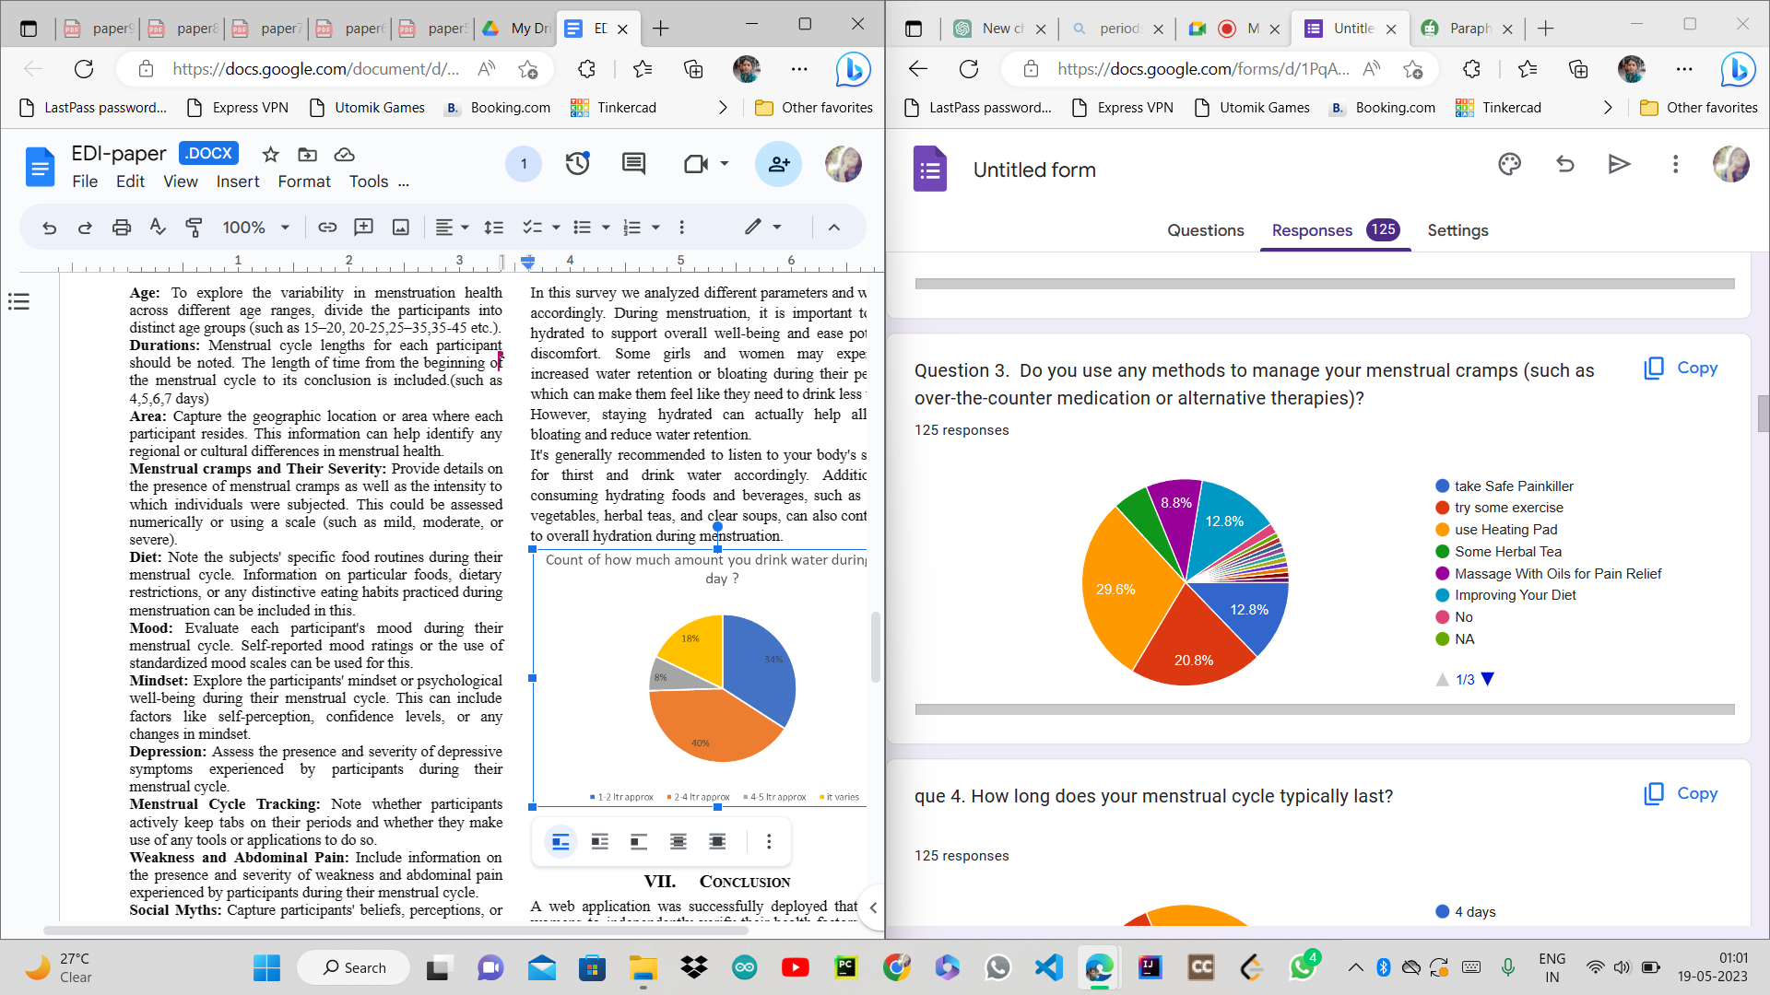

Fig no: 2 Pain-Relieving Therapie

It was observed that the maximum percentage womens tries using a heating pad for pain relieving and it helped them alot. Also practices some exercises for pain relieving.

**Diet:** Note the subjects' specific food routines during their menstrual cycle. Information on particular foods, dietary restrictions, or any distinctive eating habits practiced during menstruation can be included in this.

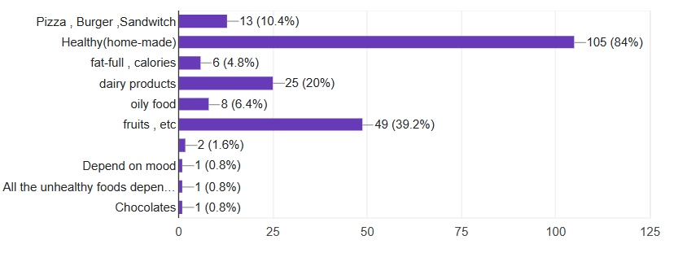

fig no: 3 Diet during MC

Most women eat healthy homemade food and fruits during periods. Still there are some participants who eat fancy food during MC.

**Mood:** Evaluate each participant's mood during their menstrual cycle. Self-reported mood ratings or the use of standardized mood scales can be used for this.

**Mindset:** Explore the participants' mindset or psychological well-being during their menstrual cycle. This can include factors like self-perception, confidence levels, or any changes in mindset.

**Depression:** Assess the presence and severity of depressive symptoms experienced by participants during their menstrual cycle.

**Menstrual Cycle Tracking:** Note whether participants actively keep tabs on their periods and whether they make use of any tools or applications to do so.

**Weakness and Abdominal Pain:** Include information on the presence and severity of weakness and abdominal pain experienced by participants during their menstrual cycle.

**Social Myths:** Capture participants' beliefs, perceptions, or experiences related to social myths or cultural taboos surrounding menstruation. This can provide insights into the impact of social norms on menstrual health.

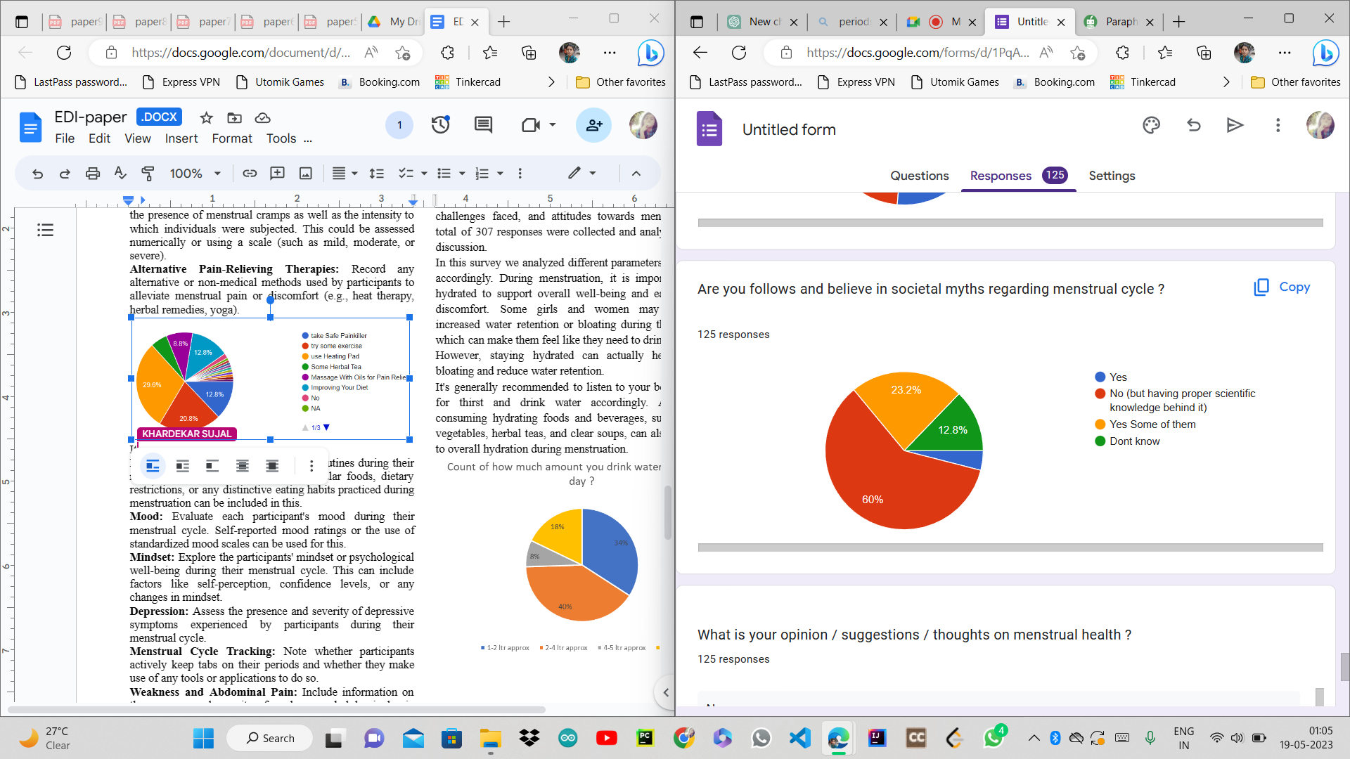

Fig no: 4 Social myths

It was a positive sign that a total of 60% womens don’t believe in superstitions or any social activity but about 23% of participants still believe some.

**Consultation with Healthcare Professionals:** Record if participants visit healthcare professionals (such as gynecologists or general practitioners) with questions about their menstrual health as well as how frequently they do so.

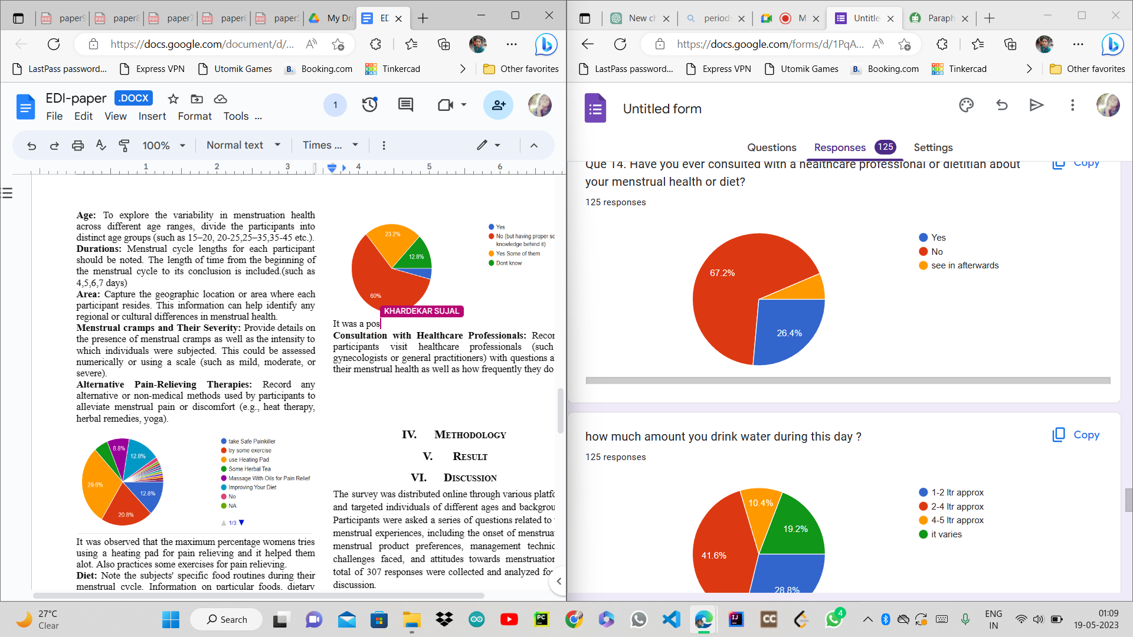

Fig no : 5 Consultation with doctors

26.4% of womens had consultation with a health professional. The remaining might belong to rural areas.

In conclusion, obtaining data for a menstrual health project survey is a crucial step in learning more about various facets of menstruation health. We can acquire useful data to analyze patterns and make well-informed decisions about menstrual health by gathering pertinent information from people, such as age, menstrual cycle duration, symptoms encountered, lifestyle habits, exercise routines, food, and associated health issues.

# **Methodology**

As per the study from above data collected during the survey , we achieved to find the solutions to given problems. For solving this problem using machine learning we solve this problem using 2 approaches one is using unsupervised learning combination algorithms like clustering and supervised learning algorithms like classification algorithms were used. The second approach is using a Reinforcement machine learning algorithm to give suggestions on the basis of it.

**APPROACH 1**

The workflow of the project using 1 st approach:

1. **Data collection:** Compile a wide range of menstrual health data, taking into account the factors described previously (age, region, length of cycle, severity of cramps, products used, etc.).
2. **Data cleaning**: Deal with missing values, get rid of outliers, and normalize or scale the data as necessary. This process makes sure the data is prepared for analysis.
3. **Feature Selection:** Use feature selection approaches to pinpoint the characteristics that are most crucial for foretelling or comprehending menstrual health outcomes.
4. **Combining Features:** Consider the potential for adding new features by fusing already-existing ones. Menstrual cramps, for instance, their severity, how they affect thinking and mood, etc. This process tries to improve the dataset's prediction capability.
5. **Clustering Algorithm:** Apply a clustering algorithm, such as K-means, hierarchical clustering, to group similar instances together based on selected features. Clustering can reveal patterns and similarities within the dataset, allowing for a better understanding of different menstrual health profiles.
6. **Data Pattern Analysis:** Analyze the patterns identified in the selected features and the assigned labels. This can involve visualizations, statistical analysis, or interpretability techniques to gain insights into different menstrual health profiles, factors influencing specific outcomes, or the relationship between features and labels.
7. **Classification technique:** Assign labels or categories to the clustered instances using a classification technique, such as decision trees, and random forests. Train the model using the features that have been chosen, and then assess its performance using the confusion matrix and check the accuracy of predicted labels by using clustering algorithms.
8. **Model Evaluation and iteration**: Assess the potency of any generated ideas or proposals. Examine their viability and the impact they may have on menstrual health. To increase the models' accuracy and usefulness, repeat the feature selection, combination, clustering, or classification process as necessary.
9. **Ideas and Recommendations:** Create a list of ideas or proposals for enhancing menstrual health based on the observed data trends. This can be achieved by identifying common traits or behaviors linked to successful menstrual health outcomes and offering appropriate guidance or interventions.
10. **Deployment of model:** Running the Flask application, which makes the model available for inference, is the last step in deploying a machine learning model using Flask. By using the app.run() method of the Flask framework and supplying the host and port to use for listening, this is accomplished. As soon as the Flask application has started operating, the model may be accessible through the specified API endpoints, enabling users or systems to make requests and obtain predictions from the deployed model.

By following this methodology, machine learning can be leveraged to identify patterns, provide insights, and offer personalized suggestions for improving menstrual health based on the selected features and the observed data patterns.

**APPROACH - 2**

Workflow Methodology for Reinforcement Learning on Menstrual Health Dataset:

1. **Data Collection and Preprocessing:** Collect a broad range of data on menstrual health, including age, the length of the menstrual cycle, symptoms, lifestyle choices, and other pertinent information. Remove any missing values, outliers, and unrelated variables as part of the preprocessing of the data. Normalize the dataset to make sure that all of the features have a comparable scale, which can aid in training.
2. **Define the Reinforcement Learning Problem:** The purpose of the reinforcement learning challenge should be made very clear. The goal might be to offer unique recommendations to enhance menstruation health depending on personal traits. Determine the steps the model can perform in response to a particular state. Actions could take the form of food adjustments, lifestyle changes, or exercise regimens. Define the reward function that measures the performance of the model. The targeted outcome, such as a decrease in menstruation discomfort or an increase in general wellbeing, should be aligned with the reward function.
3. **Design the Reinforcement Learning Agent:** choose a suitable reinforcement learning algorithm ,such as Deep Q-Networks(DQN), based on problem requirement and dataset characteristics. Consider the problem's complexity and the amount of the dataset when choosing the model's initial parameters and hyperparameter.

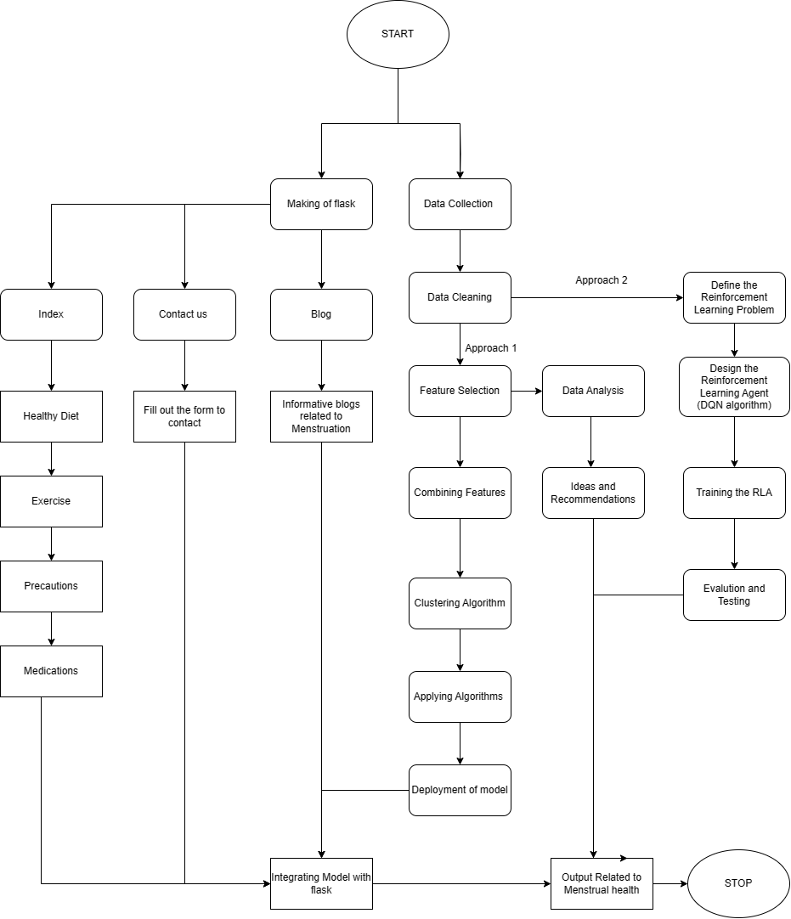

Fig no: 6 Flowchart Of Model

**Deep Q-Networks(DQN)**

DQN is a reinforcement learning algorithm designed to solve problems with a discrete action space. It aims to learn an optimal policy for an agent in an environment by approximating the Q-values (expected future rewards) for each state-action pair.

**Bellman Equation and Q-Values:**

The Q-value of a state-action pair (Q(s, a)) represents the expected cumulative reward that an agent can achieve by taking action 'a' in state 's' and following the optimal policy thereafter. The Bellman equation describes the relationship between the current Q-value and the Q-values of the next state-action pairs, incorporating the reward and discount factor:

**Q(s, a) = R + γ * max(Q(s', a'))**

**Experience Replay:**

The agent's experiences are kept by DQN in an experience replay buffer. Experiences in the form of (state, action, reward, next_state) tuples are gathered and stored in the replay buffer during interaction with the environment. Mini-batches of experiences are randomly selected during training to break up temporal correlations and boost sampling effectiveness.

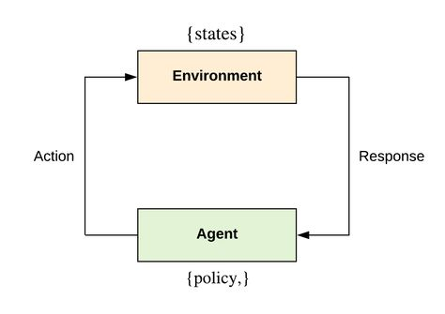

Fig no: 7 DQN Algorithm working

**Target Network:** To stabilize the learning process, DQN employs a target network. A separate target network is created, initially identical to the main Q-network.The target network's weights are periodically updated with the weights from the main Q-network.

**Exploration-Exploitation:** DQN employs an epsilon-greedy method to balance exploration and exploitation. A random action is picked with probability epsilon to investigate the surroundings.

The action with the highest Q-value is chosen with a probability of (1-epsilon) in order to take use of the new information.

**Training Methodology:** DQN uses an iterative training methodology. The agent interacts with the environment throughout each iteration, gathers experiences, and then saves them in the replay buffer. In order to reduce the difference between anticipated Q-values and target Q-values, the Q-network is trained by selecting small batches of experiences from the replay buffer and adjusting the network weights using gradient descent.

**Target Update and Learning Rate Schedule:** The target network's weights are updated periodically (e.g., every few episodes) by copying the weights from the main Q-network. A learning rate schedule is often employed to gradually decrease the learning rate during training to improve convergence.

By using the DQN Algorithm model it can give suggestions on the basis of state, actions and rewards which is beneficial for menstrual health prediction.

1. **Training the Reinforcement Learning Agent:** The dataset should be divided into training and validation sets.Utilizing the training set, train the reinforcement learning model by repeating episodes or steps. Update the model's policy while it is being trained based on the rewards gained for each activity. To balance exploration and exploitation, use approaches like exploration-exploitation strategies (such as epsilon-greedy).
2. **Evaluation and Testing :** Examine the trained agent's performance using the validation set to gauge how well it will be able to make accurate and practical recommendations for enhancing menstrual health. Examine critical indicators, such as the suggestion accuracy, response time, or sensitivity to diverse user attributes, to analyze the agent's performance and behavior. Based on the outcomes of the review, carry out any necessary adjustments or additional training to enhance the agent's performance.
3. **Deployment and Monitoring:** Deploy the trained reinforcement learning agent in a real-world setting, such as a mobile application or web-based tool, where users can input their information and receive personalized suggestions. Continuously monitor the agent's performance and collect user feedback to identify areas for improvement and ensure that the suggestions provided align with user expectations. Periodically retrain or update the agent using new data to adapt to evolving user needs and preferences.

In conclusion, applying reinforcement learning algorithms for forecasting recommendations in menstrual health based on a dataset can provide insightful information and tailored recommendations. To improve menstrual health outcomes, we can use reinforcement learning algorithms in a powerful way by taking a step-by-step approach.

# **Results**

After the step of Data analysis many different combinations were made and these combinations were used as a variable for the data training. Some of the combinations were Cramps-severity_cramps-mindset-mood,Mindset-pain-weakness-duration. Then these variables were divided into different classes and suggestions were given to the user accordingly.

**1) Cramps , Severity_cramps, Mindset , Mood :** Collect a dataset that includes information on cramps, severity of cramps, mindset, mood, and corresponding suggestions or interventions that have been effective in managing menstrual health.Analyze the features to identify any potential transformations or engineering that may enhance the predictive power of the model.

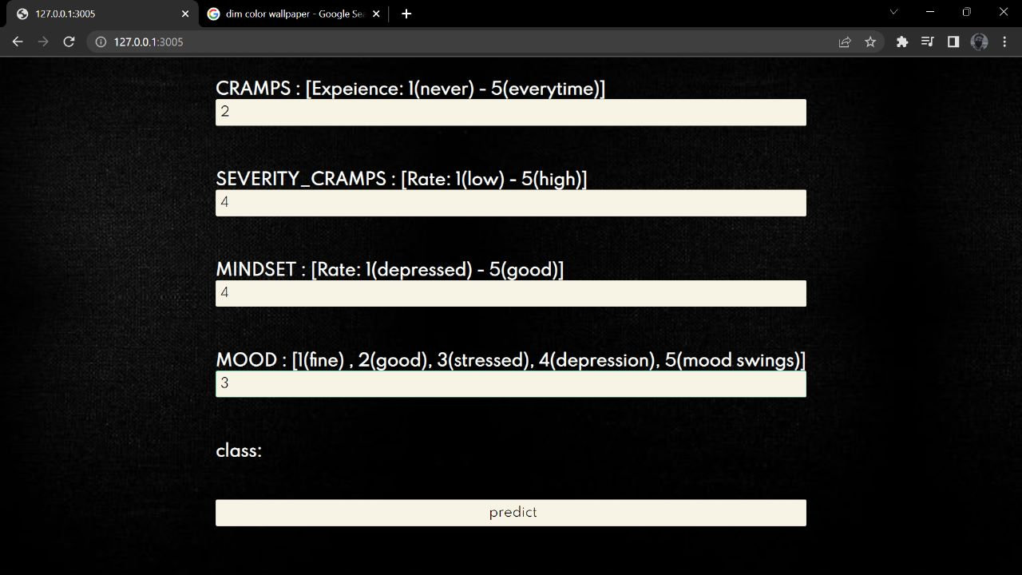

Fig no : 8 Input Form of Combination

These four variables take input from the user and with the help of a developed model it classifies into class and gives some advice to the user. The Fig no. 9 is the output of the combination of Cramps, severity_cramps, mindset, mood. It suggests some caution and remedies for the given problem.

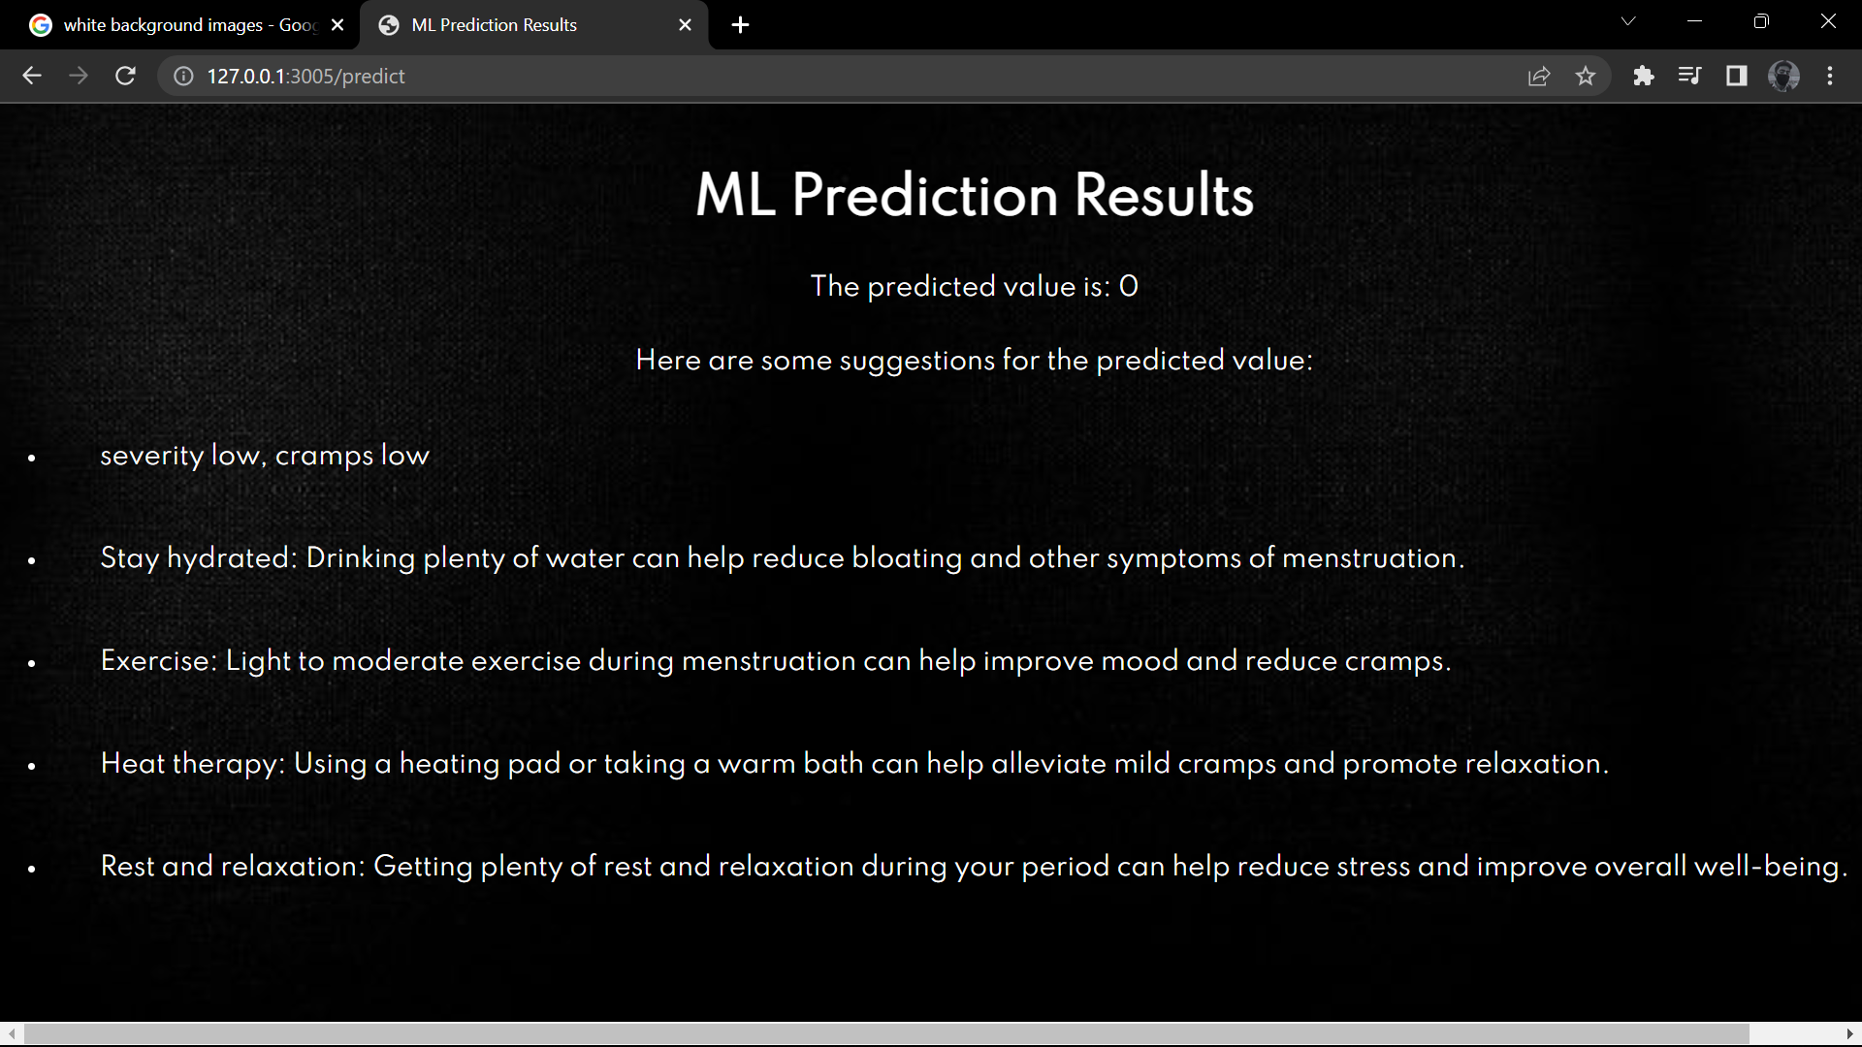

Fig no: 9 Prediction of model 1

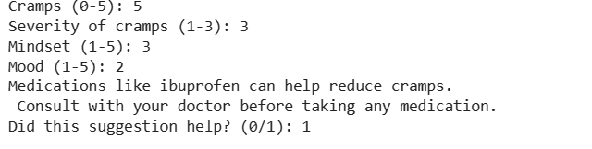

Fig no: 10 Output of Reinforcement Model

The Fig no. 10 is the output of the reinforcement model, as the cramp severity was high the model gives the output according to the severity of cramp and the combination made.

**2) Mindset, pain, weakness, duration :**The mindset of an individual plays a crucial role in their ability to learn and adapt to new information. It can vary from a growth mindset (believing in the ability to learn and improve) to a fixed mindset (believing abilities are fixed and cannot be changed easily). Pain can be a physical or emotional sensation that affects an individual's ability to concentrate, focus, or engage in learning activities.

It is essential to consider the severity and nature of the pain to determine the appropriate course of action.Identifying weaknesses in a learner's skillset or knowledge areas can help create targeted learning interventions. By duration refers to the length of time for which these factors (mindset, pain, weakness) persist. In these combinations the user gives the entry accordingly and the combination made gives output correspondingly. These combinations were made to check for the physical condition during the menstruation.

**3) Depression_or_anxiety , Mindset ,Mood,Feelings :**

The combination of depression or anxiety, mindset, mood, and feelings can provide insights into an individual's mental well-being and emotional state.

Common mental health issues like depression and anxiety can have a serious effect on a person's perspective, mood, and general wellbeing. The ability to learn or participate in other activities may be impacted by these circumstances, which may also decrease motivation and focus. A person's mindset may be more negative or self-critical while they are experiencing depression or anxiety.

A person's mood is referred to as their emotional state at a specific time. It can change during the day and affect one's motivation, concentration, and level of involvement in academic pursuits. A person can experience a wider variety of emotions than are included in feelings.

**4) Management_of_menstrual_cycle,Menstrual_product , Area, Consult :**

Menstrual cycle management refers to the practices and strategies employed to navigate the physical and emotional changes that occur during a menstrual cycle. Understanding an individual's specific needs and concerns related to their menstrual cycle can help in generating relevant suggestions. Knowing an individual's preferred menstrual product or their willingness to explore different options can help tailor suggestions related to product usage, availability, hygiene, and sustainability.The geographical area or location can impact the availability and accessibility of menstrual products and resources. Different regions may have varying cultural norms, legal frameworks, and product availability. Consultation refers to seeking professional advice or guidance related to menstrual health. This can involve consulting healthcare professionals, gynecologists, or specialists in menstrual health.

**5) Cycle_track , Management of MC :**

Cycle tracking involves monitoring and recording various aspects of the menstrual cycle, such as the start and end dates of menstruation, cycle length, and any associated symptoms or changes. Understanding an individual's cycle tracking habits and data can provide insights into their menstrual health patterns and enable personalized suggestions.Menstrual cycle management refers to the strategies and practices employed to effectively navigate the different phases of the menstrual cycle and address any associated challenges or symptoms.

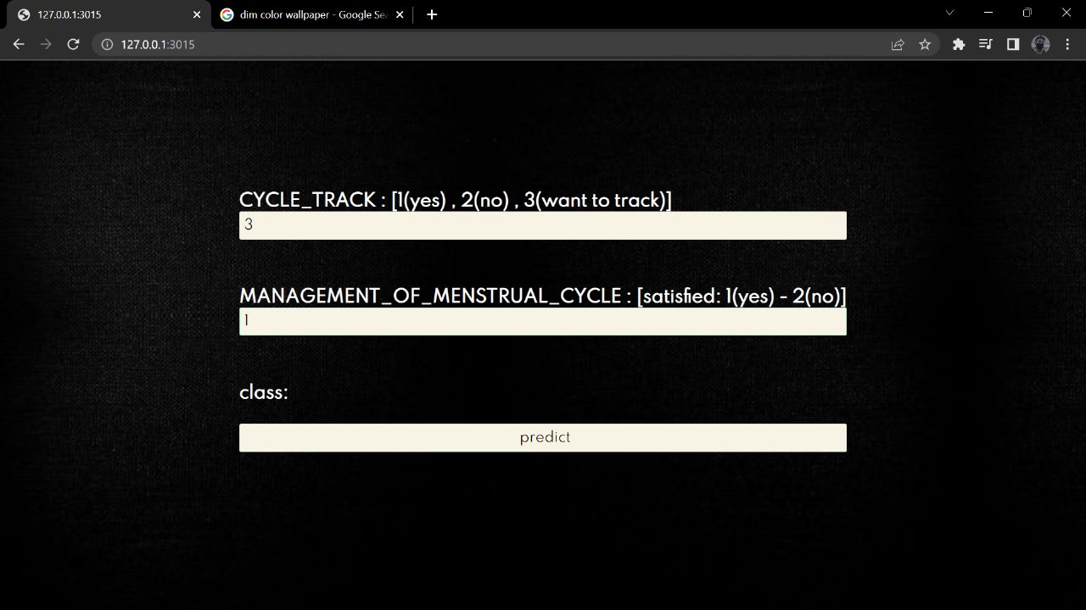

Fig no :11 Input form of class cycle_track , management

These combinations were to track the MC and ensure proper management during MC. These combinations was necessary to track health and hygiene.

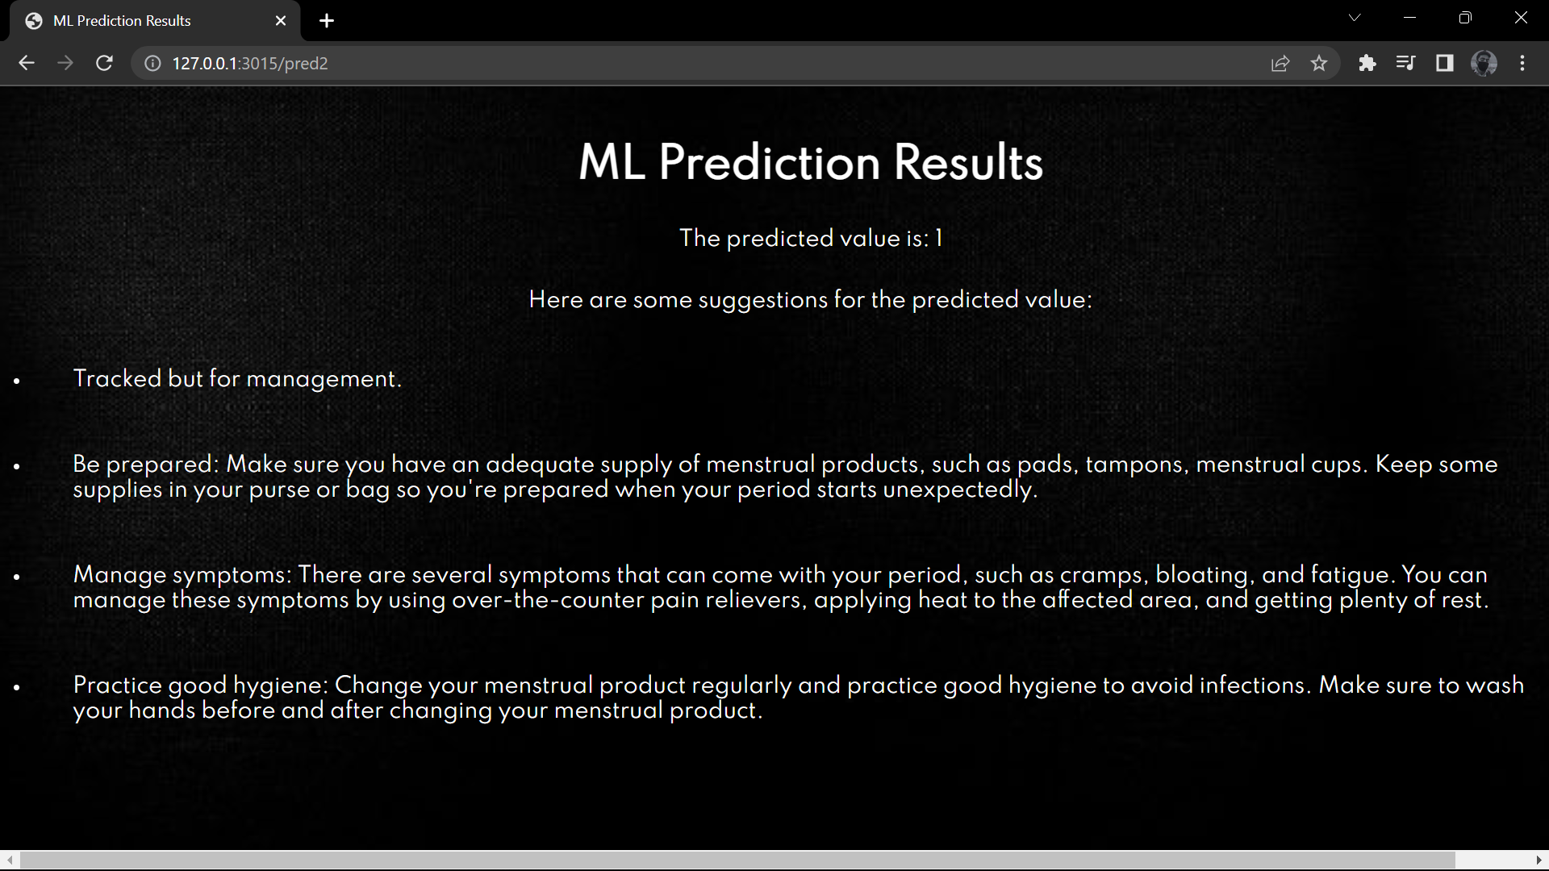

Fig no :12 Predicted Output of cycle_track , management

As shown in fig 12, The output of the cycle_track and management give suggestion to the user if the management is not proper and tracking of cycle or carelessness related to the tracking

**6) Mindset, SocialMyth, Depression:**

A person's mindset is defined as the beliefs, attitudes, and perspectives that inform their way of thinking and doing. The resilience, motivation, and capacity to handle difficulties of a person with depression can be greatly influenced by their mentality. Social myths are widely held misconceptions or prejudices that are inaccurate or deceptive.

Several social illusions about depression can contribute to stigma, misunderstandings, and obstacles to getting care.A mental health disease called depression is characterized by persistent feelings of melancholy, a loss of interest or enjoyment, changes in food or sleep patterns, low energy, and trouble focusing or making decisions.

As Fig. 13 shows, many women may experience superstition regarding menstrual cycle sadness as a result of cultural myths and misconceptions. This will negatively impact their mood, attitude (the way they view their menstrual cycle), and many other problems they encounter.

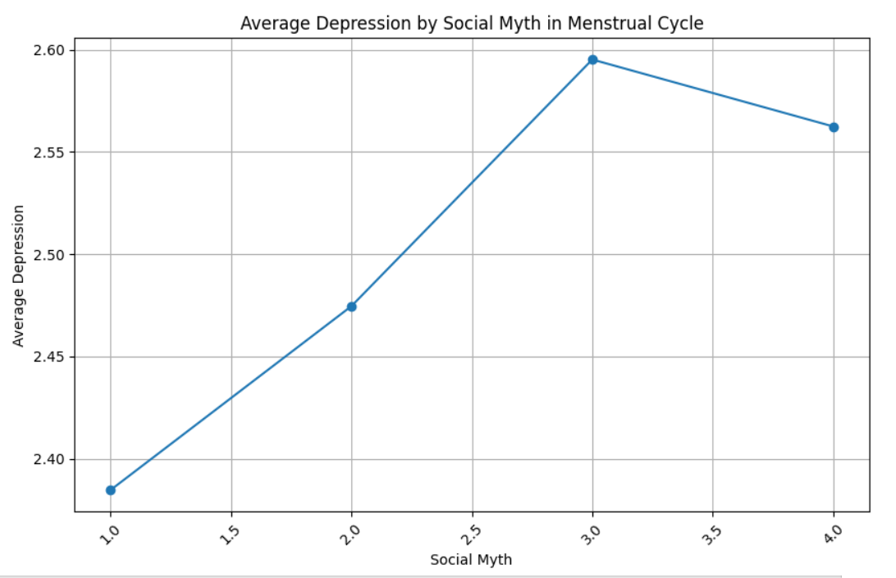

Fig no: 13 Average Depression by Social Myths in MC

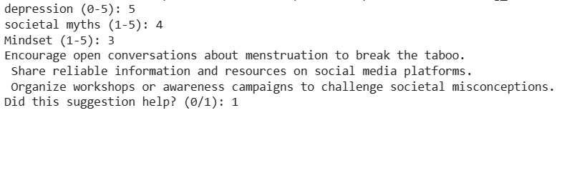

Fig no: 14 Output of Reinforcement prediction

It is important to note that machine learning algorithms should not replace professional diagnosis and treatment. They can provide supportive suggestions and information but should always be complemented with guidance from mental health professionals.

# **Discussion**

The survey was distributed online through various platforms and targeted individuals of different ages and backgrounds. Participants were asked a series of questions related to their menstrual experiences, including the onset of menstruation, menstrual product preferences, management techniques, challenges faced, and attitudes towards menstruation. A total of 307 responses were collected and analyzed for this discussion.

**Issues And Challenges:**

In this survey we analyzed different parameters and worked accordingly. Some of the important factors that we observed and studied from the survey that are discussed below.

**Sociocultural factors:**

The menstrual cycle is a biological process that is influenced by various socio-cultural factors. Here are some of them:

1. **Cultural taboos:** Menstruation is considered impure and womens are required to isolate themselves from the rest of the community during periods. These taboos can impact the way women feel about their menstrual cycles and can even lead to shame or embarrassment.
2. **Religious beliefs**: several religions have particular customs or rituals related to menstruation. For instance menstrual women are not permitted to participate in religious events in Hinduism. Women are free from prayer and fasting in Islam while they are menstruating. The daily habits of women throughout their menstrual periods may be impacted by these religious beliefs.
3. **Education:** Misconceptions and myths about menstruation hygiene and health might arise from a lack of knowledge and education in this area. In order to lessen the stigma and promote better menstrual hygiene habits, it is crucial to educate both boys and girls about menstruation.
4. **Availability to menstrual products:** How women manage their periods depends on having access to reasonably priced, secure menstrual supplies. Lack of access to such things may cause people to engage in unsanitary behaviors, which may cause health issues.
5. **Gender roles and societal expectations:** These factors can have an effect on how women handle their periods. Women in male-dominated industries, for instance, might find it awkward to talk to their coworkers or superiors about menstrual concerns.
6. **Advertising and the media:** How menstruation is portrayed in these outputs might affect how women view their periods. Menstrual products that are advertised as a solution to hide periods might add to the stigma and shame associated with menstruation.

# **Conclusion**

The Red-Revive web application has been successfully deployed, providing women with the ability to independently verify their health factors during their menstrual cycles using machine learning. With this app, users can accurately predict their periods and access information on various menstrual-related difficulties and other relevant topics. One of the key advantages of the system is that users can obtain these insights without compromising their personal information by sharing it with external sources. Overall, the deployment of the Red-Revive web app marks a significant advancement in empowering women to manage their menstrual health effectively.

# **Future Scope**

As this project was made on a small scale, the dataset collected was limited and it was difficult to predict the output. Including more questions related to menstruation leads us to have more parameters for the project.

1. Huge dataset can be collected to improve the accuracy of the Model.
2. More parameters can be predicted related to women's health.
3. Menstruation camps can be organized in society to spread awareness.
4. Integration of models with IOT devices can be made to track the health of women with the technology of big data to store the readings of health parameters.

##### **Acknowledgment**

We thank Vishwakarma Institute of Technology for providing an opportunity to share our ideas with the research community during this needed hour. Also, we thank our HOD Dr. Sandeep Shinde, our coordinator Shital Phatangare, and our EDI Project guide Anant Kaulage for their guidance.

# **References**

1. Anne Mutunda Lahme, Ruth Stern, and Diana Cooper,”Factors impacting on menstrual hygiene and their implications for health promotion”,IUHPE – Global Health Promotion ,2016.
2. Balaji Arumugam, Saranya Nagalingam, Priyadharshini Mahendra Varman, Preethi Ravi, Roshni Ganesan,”Menstrual hygiene practices: Is it practically impractical?”,International Journal of Medicine and Public Health ,2014.
3. Ram Naresh Yadav, Shrijana Joshi, Rajesh Poudel,  Pawan Pandeya,”Knowledge, Attitude, and Practice on Menstrual Hygiene Management among School Adolescents”,JNHRC-Journal – Nepal Health Research Council,2017.
4. Shreya Rastogi, Aparna Khanna,Pulkit Mathur3, “Educational interventions to improve menstrual health: approaches and challenges”,International Journal of Adolescent Medicine and Health,2019.
5. Rajesh Garg, Shobha Goyal, Sanjeev Gupta,”India Moves Towards Menstrual Hygiene: Subsidized Sanitary Napkins for Rural Adolescent Girls” , Springer,2011.
6. Takehiro Kanno, Wenxi Chen, Masumi Kitazawa ,”Development of i-apply for Women’s Health Information Management System”,IEEE,2007.
7. Sudman Bin Manjur, Nahian Noshin Nur, Md. Mushfiqur Rahman, Rohimul Basunia and Mohammad Monirujjaman Khan, “ Educational Web Application for Young People to Raise Awareness on Menstruation”,IEEE,2021.
8. Larysa Malanchuk , Mariia Riabokon , Artem Malanchuk , Serhiy Malanchuk , Svitlana Riabokon , Olha Kovalchuk,”The Use of Data Mining Techniques for Analysis of Menstrual Cycle Parameters and Prognosis of Migraine Symptoms in Reproductive Age Women”,IEEE,2020.
9. Jisan Lee, Hyeongju Ryu, Ahjung Byun, Yeonji Ko, Jeongeun Kim,”Method for Selection of the Best Application for Women’s Health”,IEEE,2017.
10. Marni Sommer, Belen Torondel, Julie Hennegan, Penelope A. PhillipsHoward, Thérèse Mahon, Albert Motivans, Garazi Zulaika, Caitlin Gruer, Jacquelyn Haver, Bethany A. Caruso & Monitoring Menstrual Health and Hygiene Group,”How addressing menstrual health and hygiene may enable progress across the Sustainable Development Goals” , Global Health Action,2021.
11. I. Melis, M.P. Penna, M. Murru , A. Pontis, M. Agus, S. Angioni, “Multidimensional assessment of pain in women with endometriosis: Preliminary results of the experience in Cagliari”,IEEE,2016.